As I informed yesterday I did some research on the ways to interface all the RFID scanners with the rpi , due to the limitations in the rfid reader and your project requirements It seems that the wired approach will be very complex to setup from your side and can cause many reliability issues. I have listed the details of what I could find about different wired approaches below .

**Wired Approach**

**SPI communication (19 pins)**

With this way a common channel with **3** wires (sck,miso .mosi) will be used to connect all the rfid scanners to the rpi . rpi will act as master and will read data from each . But for each reader it is required to connect one extra pin to enable data output in each device ,which will result **16** pins for 16 readers .

**IIC communication(2 pins)**

With this way only two wires is needed for communication ,but again due to reader limitations we can’t use this approach too . because in this method each reader need their own address to read them individually .but assigning different addresses to each device is not supported by the reader . thus the same address will be used in all the readers.

Also this communication is not recommended for communication for more than 1 meter distance .This is the major issue .

**Serial communication(2 pins)**

This is a conventional communication and can cause conflicts during multiple readings are taken since there are no addressing available. Basically no way to identify from what reader the readings came from.

Other than the above for each locker two extra wires are needed to control the LED and Buzzer . We can’t do something like multiplexing( using a separate multiplexer IC) for these because there can be several lockers open at same time ,thus we will need again **16x2** wires for this too. Since buzzers need a specific frequency to generate sound we will have to include separate frequency generators (a small circuit ) for each locker too .

Also a power line (12v) and a ground line will also need to be sent for each locker irrespective of the communication (wired or wireless)

**Wireless Approach (WiFi - MQTT)**

Other than what I have suggested to you yesterday, I have included some extra details about this approach in reference to the project.

**MQTT**

I have only included the following image to give you a high level understanding about how the connection is made in this protocol. You may be already know about this method too.

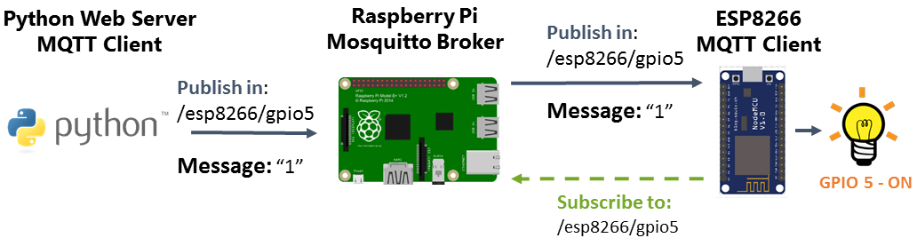

I have used mosquito MQTT application to create a local server in the rpi where each esp device will connect to . Also with python a client connection is made by rpi also to the same server .In that way the communication happens in this method .

**What Each Locker will contain**

Each locker will have a separate unit including a esp8266 ,the rfid reader ,relay ,led and buzzer . all the components will be connected to the esp8266 and it will control all of them .

**Power**

A 12v supply wire can be sent through each locker to power up each unit . each solenoid can be plugged to the respective unit .

The only downside of this approach is the extra cost for each unit due to esp8266 .([about 3 usd for one module](https://www.aliexpress.com/item/4000516449275.html?spm=a2g0o.productlist.0.0.66496af6UrJ1HY&algo_pvid=e7bcf758-869a-4da6-9e8e-ec3ce626773d&algo_expid=e7bcf758-869a-4da6-9e8e-ec3ce626773d-13&btsid=0ab6f83a15949791999143841e1e43&ws_ab_test=searchweb0_0,searchweb201602_,searchweb201603_)) .

With this type of a system you can easily port the same system for any wireless switching application.